Ready, Set, EDDIE!

# Tips & tricks for teaching the Macrosystems EDDIE: Macro-Scale Feedbacks

To download module files, teaching guides, and other course materials, please visit: <http://module4.macrosystemseddie.org/>.

# Part 1: R your computers ready?

The Macrosystems EDDIE module is run using R, an open source software program for statistics and graphing. Making sure R is installed and up-to-date on student computers before you begin teaching the module will help keep students focused on the ecology learning goals, and minimize time spent diagnosing and troubleshooting compatibility problems on computers.

If students will be completing the module on personal laptops, we recommend having them work through the “R You Ready for EDDIE” file in advance (also available from the SERC website above), so they come to class prepared to run the module. The file includes detailed directions for students to:

## Download and install R and RStudio

## Install packages used in the EDDIE module

## Download and unzip the Macrosystems EDDIE module files

# Part 2: Background on the GLM and associated files

This Macrosystems EDDIE module uses the General Lake Model (GLM), which was first developed by researchers at the University of Western Australia, in collaboration with members of the Global Lake Ecological Observatory Network (GLEON; Hipsey et al. 2019).

## Model Structure

The GLM is a one-dimensional hydrodynamic model, meaning that the lake is divided into “layers” (vertically), and within each layer, conditions are the same across the lake (horizontally). The GLM model simulates physical characteristics of the lake, including water temperature and water density, by modeling energy within each layer, and vertical mixing between layers. The model simulates the lake water balance by accounting for inflows and outflows from the lake, if specified; otherwise the water balance is constant over time.

*Schematic of GLM model: Figure 1 from Hipsey et al. (2019).*

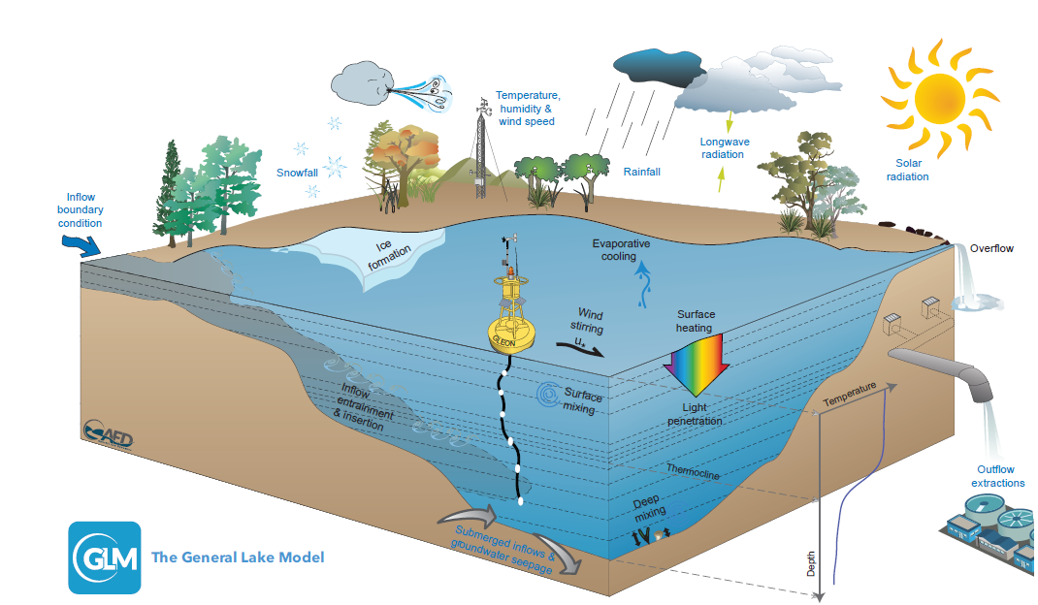

Users can run the GLM model using the R statistical interface through the “GLMr” package. Output from the GLM can be plotted and further manipulated in R using the “glmtools” package (Read et al. 2014).

The GLM can also be coupled with water quality models, including the Aquatic EcoDynamics library (AED; Hipsey et al. 2013) to simulate coupled physical, biological, and chemical processes in lakes. This module uses AED to simulate carbon dynamics within the lake.

For the Macrosystems EDDIE Macro-Scale Feedbacks module, students will run the GLM-AED model on multiple lakes, including Lake Mendota (Wisconsin, USA), Lake Sunapee (New Hampshire, USA), Lake Toolik (Alaska, USA), and Falling Creek Reservoir (Virginia, USA).

## File Types in GLM

There are several files that are required to run GLM-AED. These files have been compiled as a .zip file for the Macrosystems EDDIE module, to streamline the modeling process. Here, we provide a brief overview of the file types used in the model.

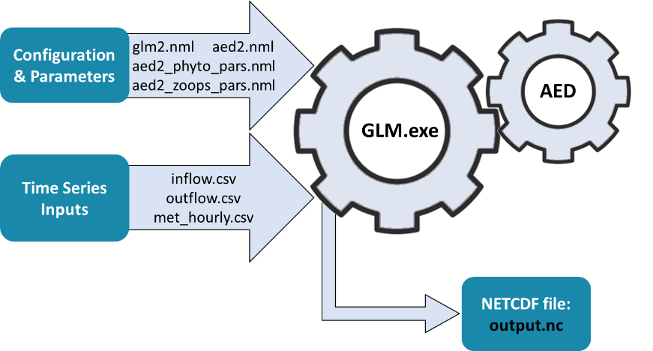

*Simplified diagram of GLM-AED input and output files used in the Macrosystems EDDIE module. Modified from Hipsey et al. (2014).*

### Model Inputs:

* **glm2.nml**: This file (the “.nml file”) provides details of the overall model configuration, via many different model parameters that can be specified, or use default values.
  + These parameters include information on lake morphometry, meteorology, lake inflows and outflows, and information about the timing of the model simulation.
  + The .nml file can be opened and changed directly within RStudio.
  + In the .nml file, lines that begin with an exclamation point (!) are not read by the program and are used to annotate the file.
  + **Important note**: The .nml file must *always* be named glm2.nml in order to run correctly in the current version of the GLM model.
  + In addition, if you edit certain values in the .nml file, check that quotation marks are straight up down vs. curved: e.g., sim_name = 'Awesome Lake' is correct; sim_name = ‘Awesome Lake’ is not.
  + The students will need to edit the glm.nml meteo_fl (meteorological file name) to run their climate change scenarios.
* **aed2.nml**, **aed2_phyto_pars.nml**, and **aed2_zoops_pars.nml**: These .nml files provide parameters that configure how the chemical and biological variables are run in the lake model. As in the glm2.nml, each of these files includes many different parameters.
* **met_hourly.csv**: This file contains a time series of meteorological (“met”) data used to drive the GLM model. Specifically, this file provides hourly values of shortwave and longwave radiation, air temperature, relative humidity, wind speed, rain, and snow. For the Macrosystems EDDIE Macro-Scale Feedbacks module, the time series includes met data from 31 December 2012 to 1 January 2014. The different climate change scenarios the students will run are altered met_hourly files (e.g., met_hourly_plus2.csv) that have modified air temperature data that is either +2, 4, or 6°C warmer relative to baseline conditions each day of the model run.
* **inflow.csv:** This file contains a time series of the water volume flowing into the lake, as well as physical and chemical variables that describe the inflowing water.
* **outflow.csv:** This file contains a time series of outflow volume from the lake. No water quality variables are included in this file.

### Model Outputs:

* **output.nc**: This file contains the hourly output of the GLM model and includes water temperature and density of each vertical layer. The output time series can be used to produce heatmaps for the lake profile over time for many variables. In this module, student will be focused on visualizing water temperatures and fluxes of carbon dioxide and methane in their lakes (see examples on next page).

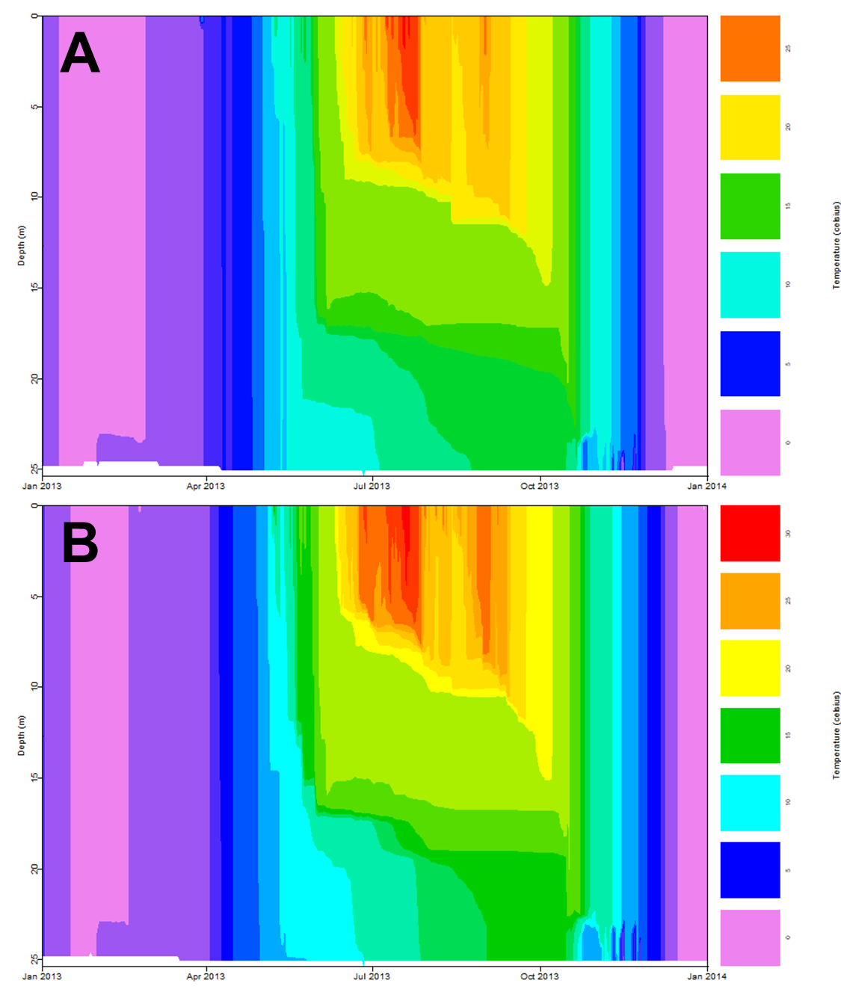

Example heat maps produced from Macrosystems EDDIE module showing Lake Mendota water temperatures across water depths and over time in the (A) baseline and (B) +4°C scenario. Note that the color scales may differ between plots.

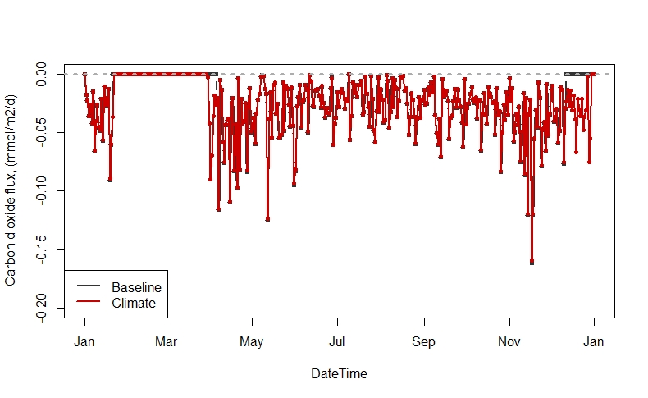

**A**

**A**

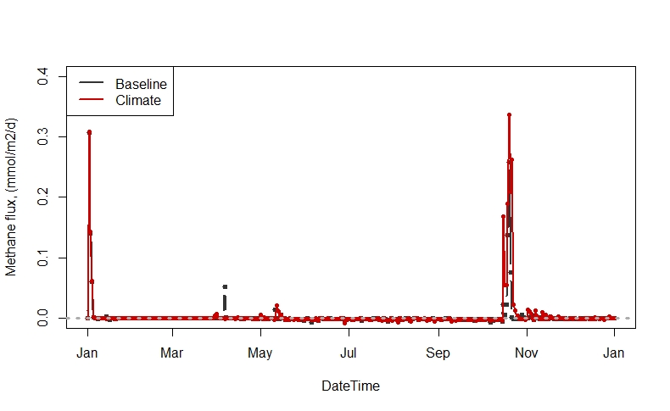

**B**

Example time series plots showing Lake Mendota (A) carbon dioxide and (B) methane fluxes over time for the baseline (black) and +4°C (red) scenarios. Note that the y-axes differ between plots.

# References

## GLM and AED model documentation:

Hipsey, M. R., L.C. Bruce, and D.P. Hamilton. 2013. Aquatic Ecodynamics (AED) model library and science manual. Draft v4, The University of Western Australia, Perth, Australia. 34 pp.

Hipsey, M. R., L. C. Bruce, C. Boon, B. Busch, C. C. Carey, D. P. Hamilton, P. C. Hanson, J. S. Read, E. De Sousa, M. Weber, and L. A. Winslow. 2019. A General Lake Model (GLM 3.0) for linking with high-frequency sensor data from the Global Lake Ecological Observatory Network (GLEON). Geoscientific Model Development 12:473–523.